Plasticonnect

Functional Specifications
Version 1

Prepared by
Last Signal

Contents
DOCUMENT HISTORY 3
PURPOSE 4
SCOPE 4
ASSUMPTIONS 4
OUT OF SCOPE 4
DECISIONS 4
DELIVERABLES 4
APPLICATION 4
1.1 Application Roles 4
1.1.1 Plastics Consumer 4
1.1.2 Supplier 5
1.1.3 Business Administrator 5
1.1.4 Support Users 5
1.1.5 System Administrators 5
1.2 Website Layout and Design 5
1.2.1 Login page 5
1.2.2 Registration 6
1.2.3 Home Page 6
1.2.4 Requisition Manager 8
1.2.5 Predefined Products Page 10
1.2.6 Product Manager Page 11
1.2.7 Supplier Selection Page 13
1.3 Reports 14
1.4 Glossary 14

DOCUMENT HISTORY

Version | Creation/Revision  Date | Created/Updated by | Comments
1.0 | Jan 17, 2011 | Bahram Daneshgar | Document Creation
1.1 | Jan 23, 2011 | Bahram Daneshgar | Added Product Manager Mockups
1.2 | Jan 25, 2011 | Serjik Dikaleh | Corrections
1.3 | Jan 25, 2011 | Bahram Daneshgar | Applied Serjik’s corrections and answered the review questions
1.4 | Jan 25, 2011 | Bahram Daneshgar | Added Product Manger descriptions
1.5 | Jan 26, 2011 | Bahram Daneshgar | Added Predefined Product concept and pages
1.6 | Jan 29, 2011 | Bahram Daneshgar | Project Named Plasticonnect.  Added the “Requisition Manager Tool” spec.  Added “Supplier Selection” spec

PURPOSE
The purpose of this document is to define a system that can be placed between plastics suppliers (manufacturing or reseller) and consumers. The Project will help consumers to get quote from different suppliers for the same product. Once a consumer submits a requisition, the system will request a quote from the registered suppliers simultaneously and report all of them back to the consumer.

SCOPE
Anything not identified in this document and project plan is out of scope. Out of scope items can be included in the project by submitting a signed and approved change order outlining details of the change requested along with any impact to original schedule and/or costs.

ASSUMPTIONS
TO BE IDENTIFIED

OUT OF SCOPE
TO BE IDENTIFIED

DECISIONS
TO BE IDENTIFIED

DELIVERABLES
TO BE IDENTIFIED

APPLICATION

Application Roles

Plastics Consumer
Plastics Consumers are the major users of the application. They are either the end users or the resellers (distributors). They should be able to do the following even before logging in:
- To define a custom product
- To add a custom product to the requisition (shopping cart)
They should be able to do the following once they are logged in:
- To save a custom product with a specific name (part number) for the future use; the name will be unique at the user level.
- To submit a requisition to a specific list of Plastics Suppliers; the list is limited to the registered suppliers in the application and plastics users are able to choose to select between them.
- To place an order by changing a quote to a purchase order

Supplier
This group of users provides the plastics goods. They should be able to do the following:
- Fulfill and price the requisitions and change them to quotes and submit them to the plastics consumers
- Receive purchase orders to be fulfilled (manufacture/acquire, receive payment and ship)

Business Administrator
This group of users has the highest authority in terms of business administration. They have access to the accounts of the suppliers and consumers. They can also generate and view business reports.

Support Users
The Support Users are the users are located in a call center and answer the phone calls or reply to fax and email communication from consumers and suppliers. They are able to create/modify accounts, logs customer calls and escalate issues to the business administrators. They are also able to reset passwords.

System Administrators
This group of users is the technical users. They have the ability to assign roles, configure system parameters and get the administration reports.

Website Layout and Design

Login page
Login page includes the regular user id and password fields. The same login page is used for different application users.
Login page has a link to reset the password (forgotten password)
There are two different registration links on the login page: registration for suppliers and consumers. See Registration
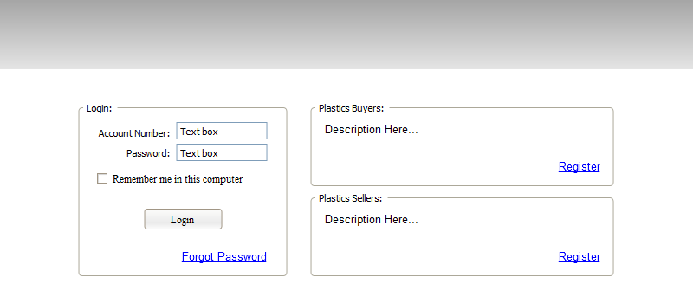

Registration
Consumers can register themselves using the Plastics Consumer Registration page. They are also able to ask support to register them over the phone. Suppliers can only be registered by Business Administrators.
Business Administrators are created by system administrators. (This can be done in the database level and no page is required)
Creating system administrators also can be done in the database level and no page is required.

Home Page
Home page will be different based on the role of authenticated users.

Anonymous Users’ Home Page
Users are able to perform certain activities before logging in. Most of these activities relate to finding information. However, there is an important activity that they should be able to perform, which is the ability to create a quote. Additionally they should be able to make custom products and add them to the quote.
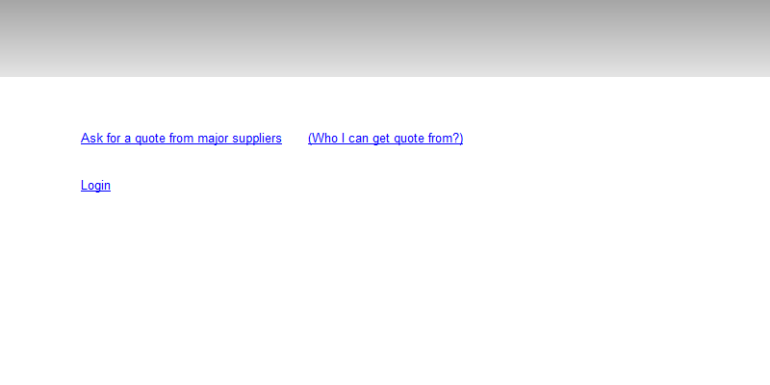

Consumers Home Page
Consumers see system related messages in the top section of the page contents
The main area of the consumer page is the Bulletin section. All business related notification appears on this section and user is able to click on any of them to perform the corresponding actions.
List the different type of Bulletin Actions

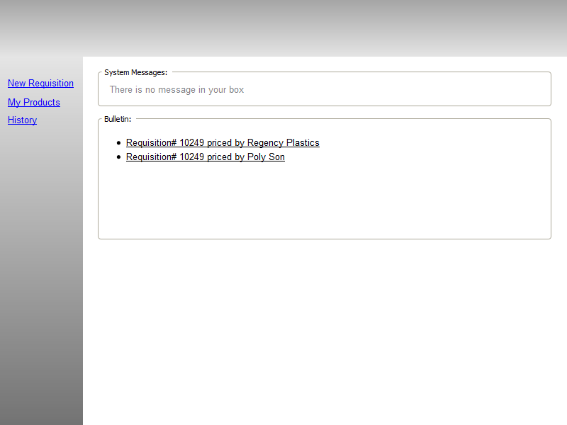

Suppliers Home Page

Business Administrators Home Page

System Administrators Home Page

Requisition Manager
Requisition Manager is a tool to create and modify a requisition. The focus of this tool is enabling user to create/modify the delivery options and create/modify the items.
Requisition Manager acts different in the different circumstances. Anonymous users should have the ability to create custom products and create a requisition. However, the system will ask them to login/register once they want to submit the requisition.

 | Anonymous User | Authenticated User
Bill to | Stays empty | Displays the registered account name and address, phone and fax
Ship to | Stays empty | Displays a textbox for the user to enter the postal/zip code of the destination. Also displays a combo box showing a list of available predefined ship-to locations. Selecting any item in the list will replace the postal/zip code with the corresponding selected item code.
Items | Displays three columns: Qty, Product and Unit Price.  Qty will be a textbox enable to enter number. There would be two links attached to the qty textbox enable user to ask for the “Minimum Qty” and “Best Price Qty” describe these | Same as anonymous

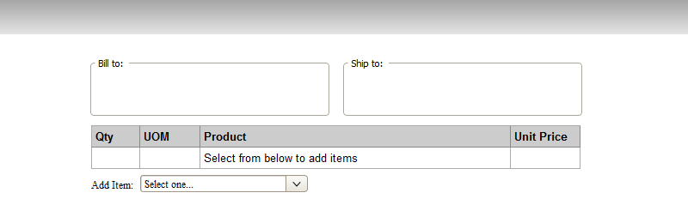

The system will redirect users to the product manager module upon selecting the product from the Add Item combo box.

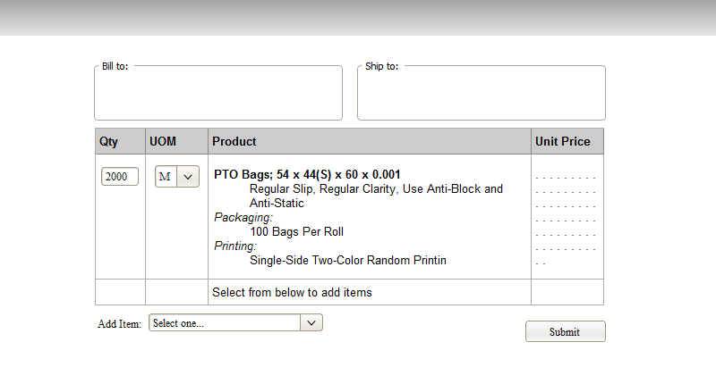

Predefined Products Page
Consumers should be able to define a product and save it for the future single or multiple uses. They save products by their part number. Part number is a unique string within a consumer scope. Different consumers can have the same part number assign to any product definition that they make. Adding a new product to the list is done by redirecting to the product manager page.
Part number validation: to be identified
Predefined Product Page displays a list of products that have already been added.
Consumer should be able to change any of the items by being redirected to the product manger page.
Consumer should be able to delete a predefine product. This action does not affect any existing usage of part number on the previously submitted requisitions, quotes or orders.
Consumer should be able to rename a part number as long as the new name is not a duplicate name. This action should be done on this same page.
Consumer should be able to add any of the existing items in the list to the Active Requisition. This action causes the user to be redirected to the Requisition Manager Page.
Consumer should be able to filter the list by typing the part number in the provided search box. As soon as the user starts typing, the list should be filtered by the search pattern through the part numbers only. Need to be discussed.
When the list is empty the page looks like the following:
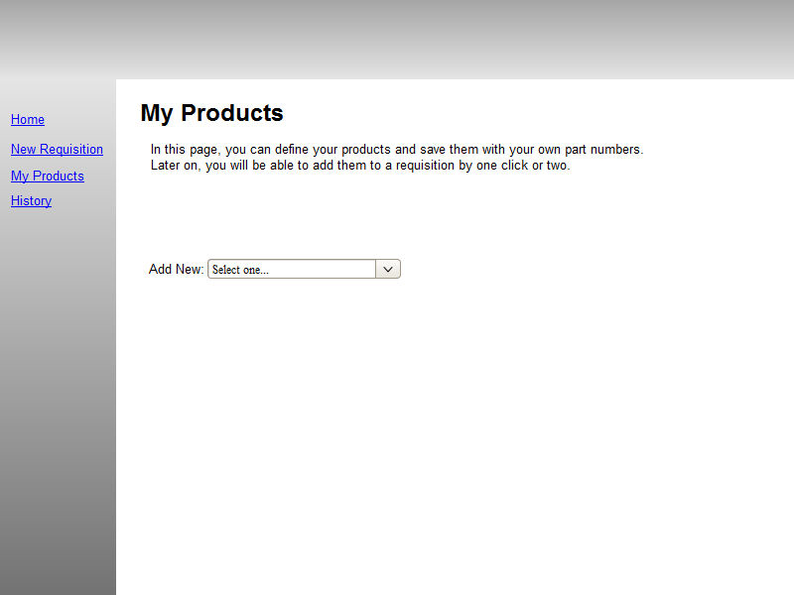
Here is a mockup of the page when it has some items in it:
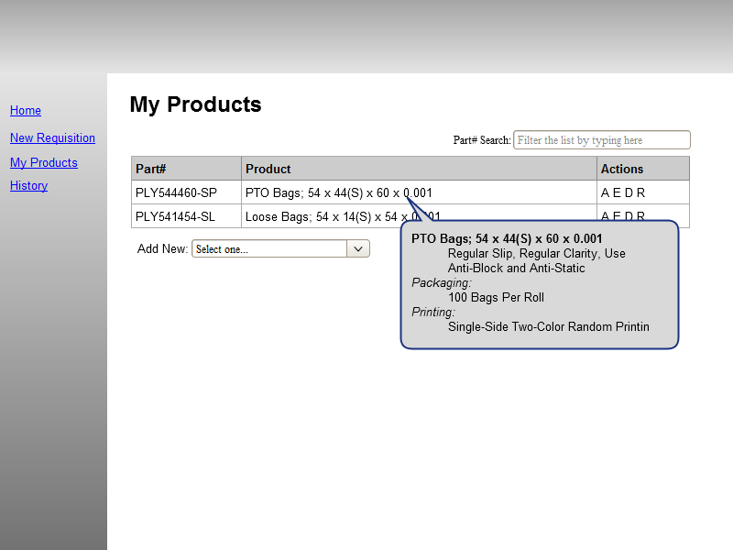

Product Manager Page
Product Manager is the tool to create or edit custom products.
This module should be available for anonymous users as well as the authenticated users. The output of the module can be added/overwritten to a requisition or saved/overwritten as a predefined product
Describe Predefined Products
Once user types the values in, the corresponding description should be updated on the page.

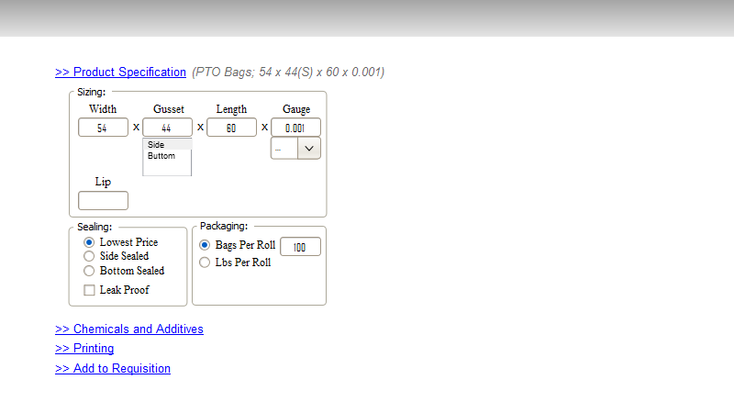
Different sections of the module are acting as accordion. Selecting one section header causes the others to be collapse.
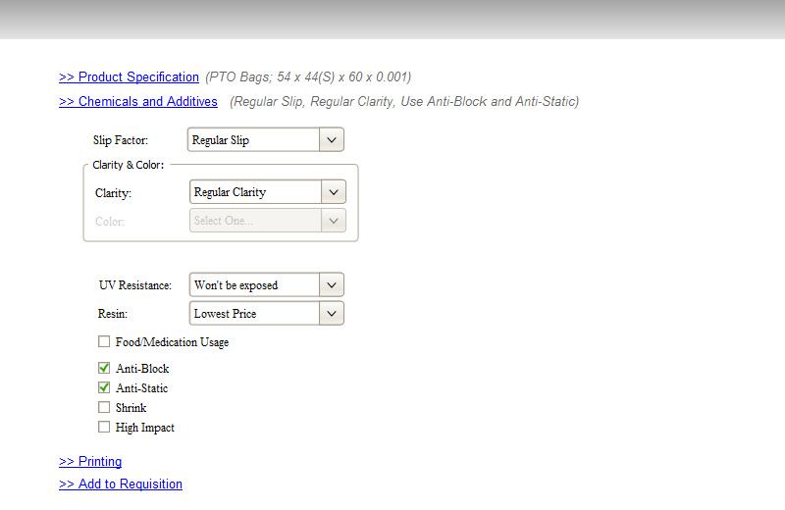
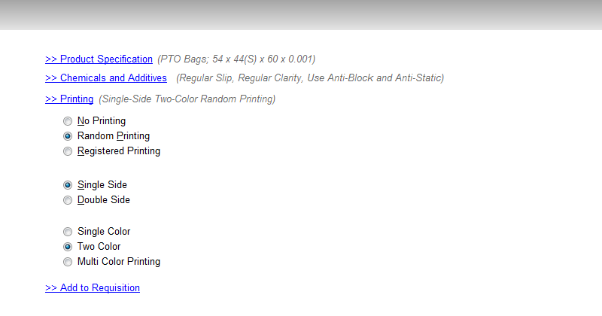
In the last section, the description of the item is displayed. If there any validation error exists, it will be shown up in red guiding user to fix it.
In addition, there should be an area for the user to assign a part number to the product. This will cause the product to be saved to the Predefined Products List. If the part number is entered, an additional text box should appear for the user to enter any optional notes for the product.
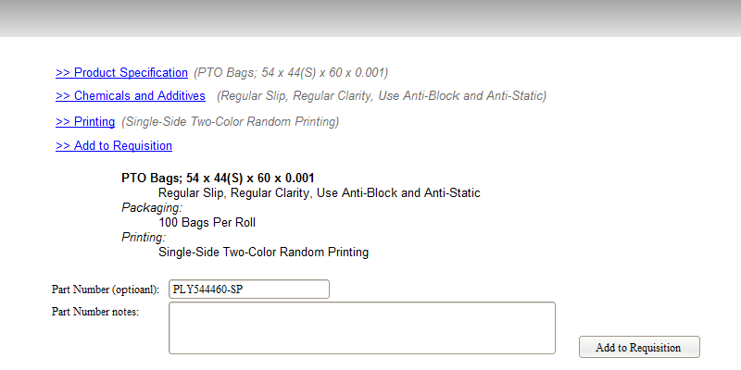

Supplier Selection Page
The page appears upon submitting a requisition asking for a quote. Consumers are able to choose to whom they want to request for a quote. The system will show a list of all suppliers who are able to provide the items based on the item description and are able to ship to the destination location.
In addition, the system gives users the option of adding a new supplier. If a consumer fill the new supplier information and submit it, the system will notify all Business Users to take the proper action in order to add the supplier to the list of suppliers.
The system will redirect user to the history page.

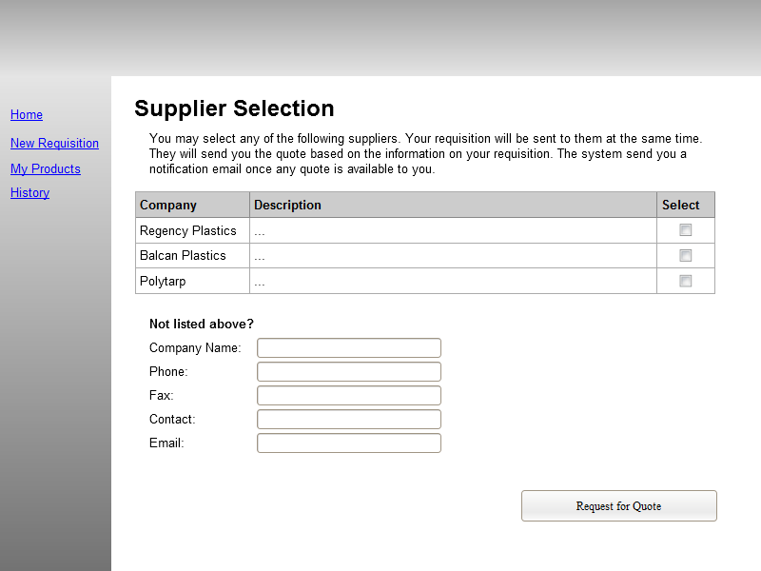

History Page
The history page displays the consumer activities in a list.
To be identified

Reports

Page Flow
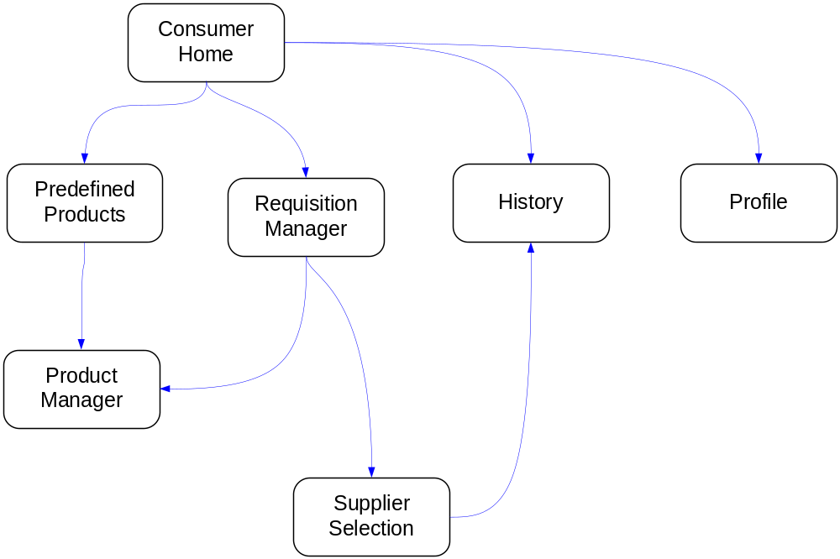

Glossary
Requisition
A request for a quote that is submitted by the Consumer
Quote
Order
In this document Order are the same as Purchase Orders
PO
See Purchase Order
Purchase Order
Approved quote by the plastics users. This is the contract document between the end user and the supplier in regards to the purchase.
System Admin User
Business Admin User
Supplier User
Suppliers can be plastic manufacturers or plastics distributors.
Plastics User
End user of the plastics which are the most popular users in the application

